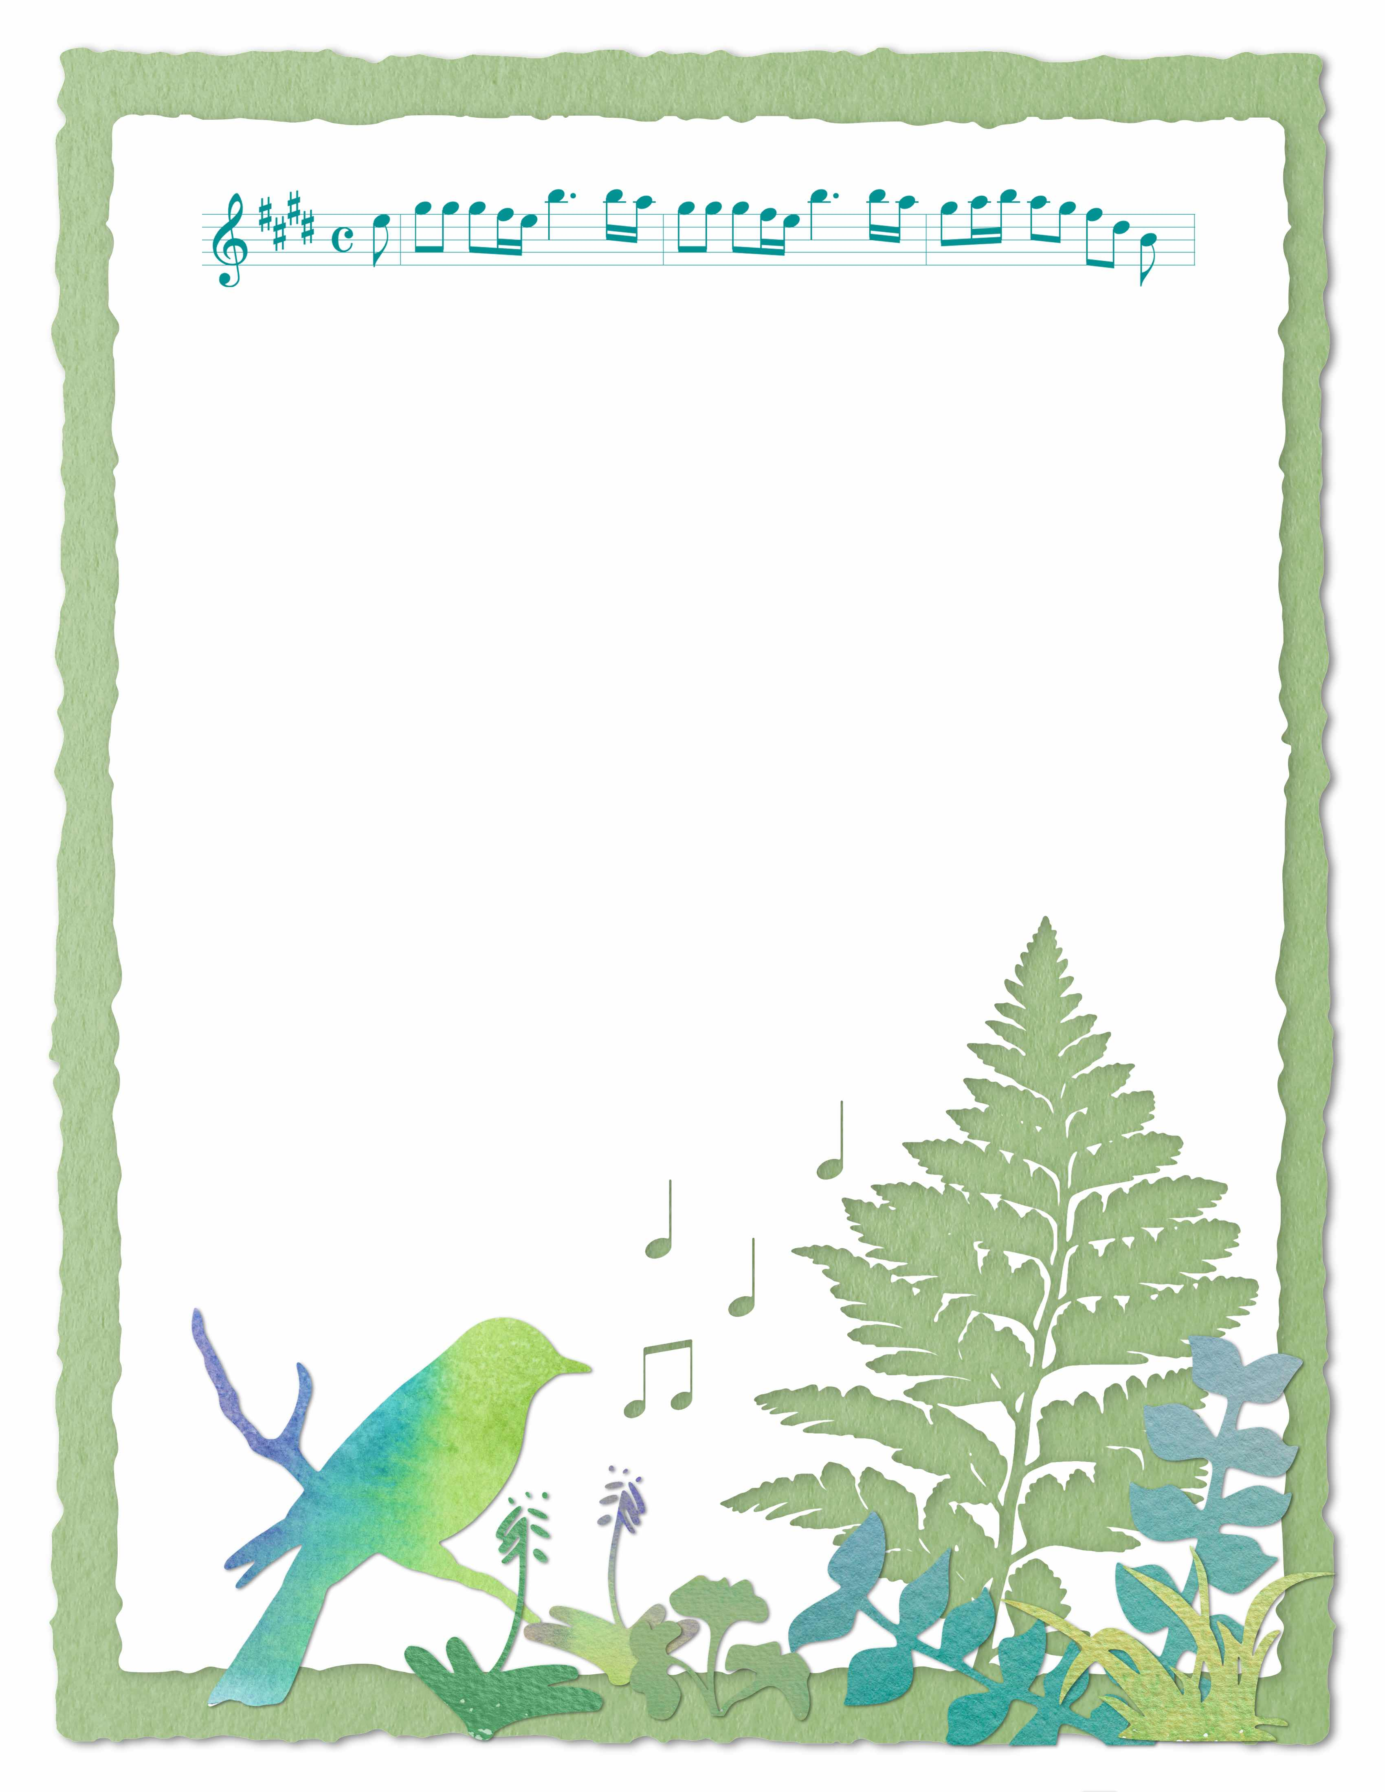
Please join us for an evening of beautiful music on the patio featuring the
piano students of Shannon Janssen!

Date: Friday, May 31st
Time: 7:00 p.m.
Location: Back yard of 1702 West 4th Street
Rain Location: First Baptist Church
(Von Maur Performance: June 5th, 6:30 p.m.
Spring Recital

